Mail Merge in Google with Mailmeteor

Table of Contents

Introduction 1

What You Need 1

Overview 1

Installing Mailmeteor for a Single Account 2

Creating a Mail Merge from a Google Sheet 2

Composing the Email 2

Previewing and Sending the Email 4

Creating a Mail Merge from the Dashboard 4

# Introduction

Using a mail merge to send out a large number of personalized emails can be incredibly time-saving. Mailmeteor is a plug-in designed to work with Google Sheets and Gmail that facilitates this process.

An individual free account allows you to send 50 free emails per day through Mailmeteor.

The free education program offers a free account to all staff and students at a school, college, or university and provides complete access to Mailmeteor's Premium features which includes a 500 emails per day sending quota and allows attachments. The Free Education Program must be installed by the Google Administrator domain-wide.

# What You Need

You will need the following:

* Gmail account ending in .edu
* Mail Meteor plug-in from mailmeteor.com <https://mailmeteor.com>

# Overview

The educator version of Mailmeteor allows you to send 50 personalized emails per day. If you require more than that, visit <https://mailmeteor.com/pricing>

If you work for a school or university, visit <https://mailmeteor.com/education-program>. The account will be free. Your email address must be a school account (ending in .edu).

Once you’ve installed Mailmeteor, there are 4 simple steps:

1. Gather merge data.
2. Compose email.
3. Add recipients.
4. Preview & send.

# Installing Mailmeteor for a Single Account

1. Navigate to <https://workspace.google.com/marketplace/app/mailmeteor/1008170693301>
2. After reading the details, click **Install** in the upper right corner.
3. At the *Sign in with Google* page, choose the Gmail account you will be using.
4. Review the permissions being granted and click **Allow**.  
   A pop-up appears notifying you that Mailmeteor has been installed as a Workspace Add-on.
5. Click **Next**.  
   A pop-up appears notifying you that additional setup is required before you can start using it.
6. Click **Complete additional setup now**.  
   A new window opens. This window has a free video-based course that you can choose to watch either now or at a later time.
7. Click the red **Add to Google Sheets** button at the top right in the menu bar.  
   The browser window navigates back to Mailmeteor in the Google Workspace Marketplace.
8. Read through the information on this page.

# Creating a Mail Merge from a Google Sheet

1. Open a new Google Sheet.  
   On the right-hand side you will notice a new icon  and blue notification box indicating: *Mailmeteor was installed. Open the sidebar to use Mailmeteor in Google Sheets*. Click **Got it** to close the notification box.
2. Name the Sheet and enter in the merge data you will use.

**Example Data**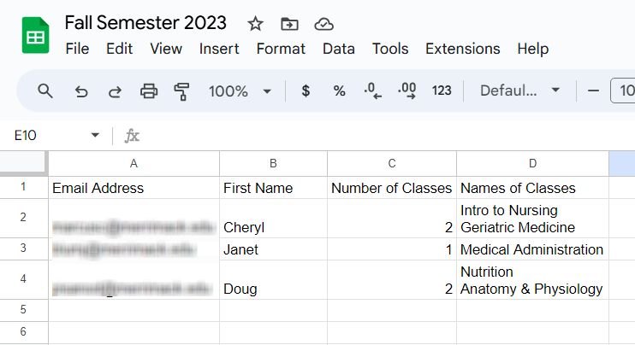

# Composing the Email

1. In the menubar at the top, **Click Extensions | Mailmeteor | Open Mailmeteor**.  
   Note: The first time you open Mailmeteor, Google will request additional permissions. Continue through the initial windows to grant access.
2. In the Mailemeteor popup window, click **Create a template to start sending emails**.

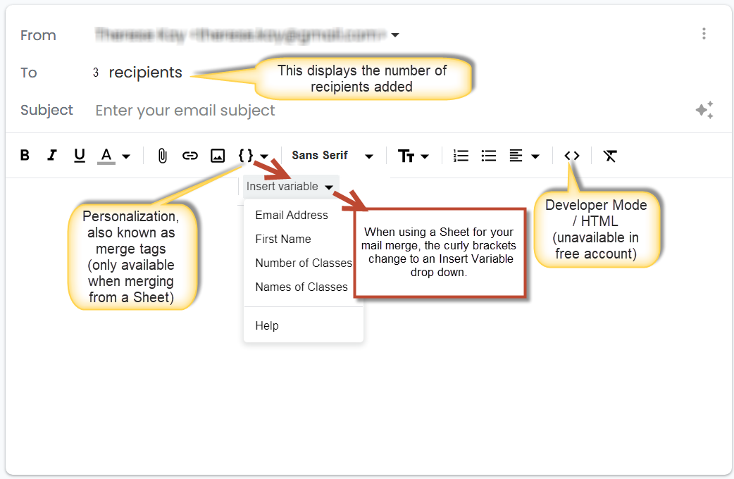

1. Enter your subject line and compose your email.   
   Variables are available to personalize your email. The variables are based on data in your sheet.

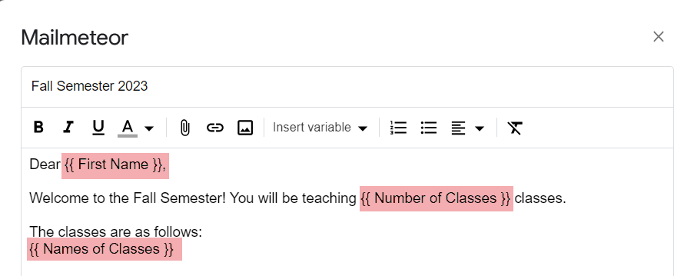  
Note: Variables are indicated by double-curly brackets only. Highlighting has been added for visibility.

1. Click **Save template**.  
   The screen returns to the Mailmeteor pop-up. The name of your template is shown in the *Email Template* field.

# Previewing and Sending the Email

1. Click **Preview emails** to review the emails and ensure the variables are correct.
   * Click the **arrow** icons  to navigate through the emails.
   * Click the **pen** icon  to go back and edit the email.
   * Click **Back** to return to the main Mailmeteor pop-up window
   * Click **Receive a test email** to send a test email to the sender’s gmail account.
   * Click **Send emails** if you wish to send the mail merge immediately.
   * Click the arrow next to **Send emails** to select one of the other mail merge options.

|  |  |
| --- | --- |
| **Send Option** | **Description** |
| Schedule Send | Select date and time. Click **Apply**. |
| Autopilot | Define your settings and allow mailmeteor to select sent options to increase deliverability.  NOTE: Only for powerusers. |
| Track emails | Toggle on or off  NOTE: paid feature |
| Unsubscribe link | Toggle on or off  NOTE: This is only necessary for newsletters with subscribers. |

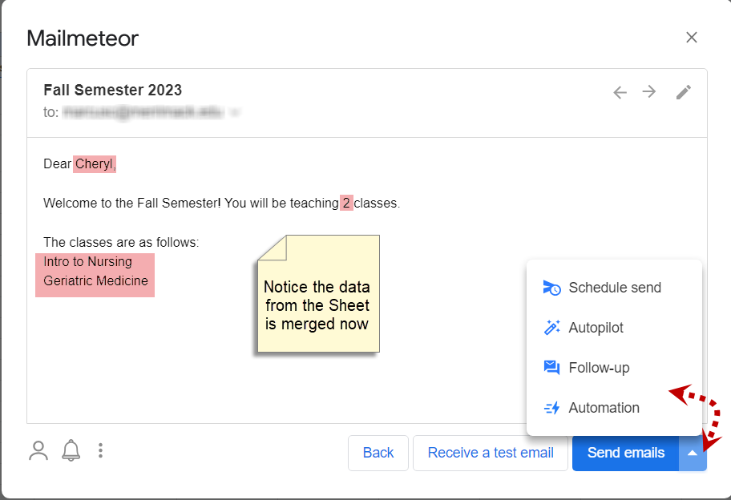

# Creating a Mail Merge from the Dashboard

You can send an email directly from the Mailmeteor dashboard without using a Sheet. Personalization is not an option if you merge from the dashboard. This is perfect for general announcements for which you want to keep the email addresses of other recipients private. If you would like to utilize this option, please refer to the *Mailmeteor Dashboard* quick reference sheet.